**Oasis of Silence**

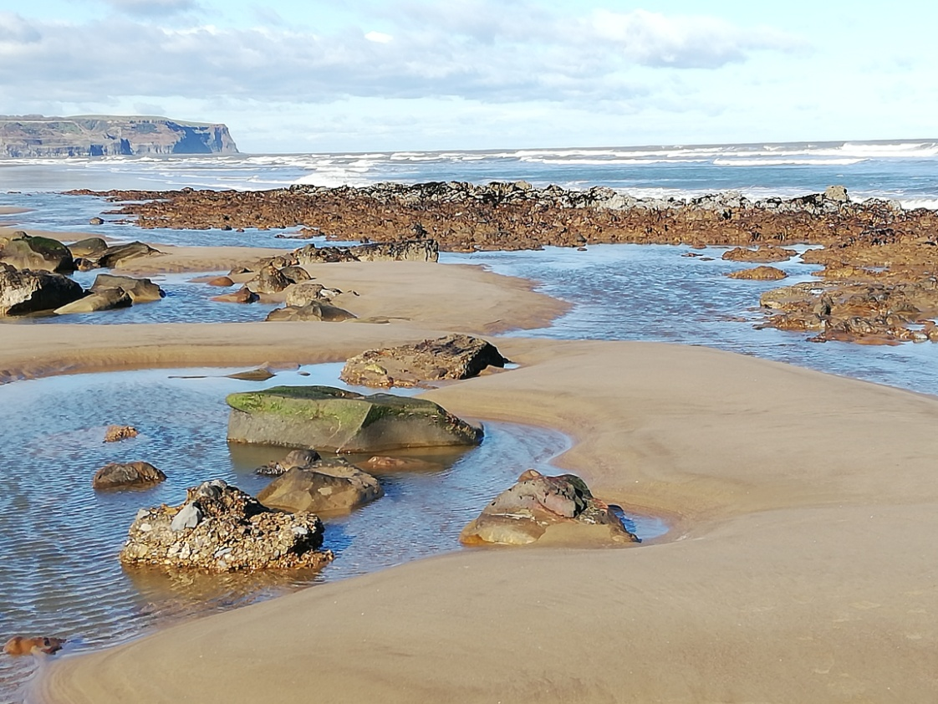

**St. Hilda´s Priory,**

**Whitby**

**2025**

**Come to me,**

**all you who are weary and burdened,**

**and I will give you rest.**

**You will find rest for your souls.**

*(Matthew 11,28)*

The Oasis of Silence programme at St. Hilda´s Priory offers space and stillness to seek God with loving awareness in the present moment. It offers a variety of opportunities to make retreats of different lengths in a peaceful and welcoming environment, away from our busy everyday lives.

It is for everyone seeking stillness and silence and who is interested in getting to know or to deepening the practice of contemplative prayer.

“There are many techniques leading to contemplative prayer,” the Jesuit, Franz Jalics SJ (1927 – 2021) used to say, “I teach only one of them.” We keep to the form and the dynamics of his method (also known as the Gries Path) in this retreat programme. Through a deepening awareness of the reality of the present moment by focusing on our breathing, our hands and His Name we are led to an ever deeper encounter with Jesus Christ

**One day retreat courses**

**Oasis of Silence**

This one day of retreat is offered on Saturdays once a month. It is hoped that this will become a regular meeting point for anyone on the contemplative path of prayer.

Everyone is welcome – whether you are just beginning to explore this form of prayer or if you have been on the contemplative path for a while.

**2025**  (proposed dates – please check and register !)

**18th January 12th April 19th July (not in August/September)**

**8th February 24th May 18th October**

**15th March 21st June** **22nd November**

**13th December**

**Arrivals from 9.30** for a **10 am start**.The day finishes around **4.30 pm**

We begin with a cuppa on arrival - and a chance to catch up with others.

Each day starts with gently guided meditations which become increasingly more silent. We enjoy a simple lunch (soup and a roll) together in shared silence. During the lunch break and afternoon there is opportunity for individual conversations with the retreat guide. The afternoon session begins with a reflection on Scripture before time spent in meditation or out in the peace and quiet of the lovely Priory gardens and countryside around.

The day ends in time to enjoy a little of Whitby, if you so wish, before returning home.

You are very welcome to make a weekend of it by using the Priory bed and breakfast possibilities. However, please note that the prices to be expected are standard prices, NOT retreat rates).

**4 day retreat courses**

**Tasting the Silence**

**Spring retreat: Thursday 1st – Sunday 4th May 2025**

**Autumn retreat: Monday 20th – Thursday 23rd October 2025**

This short form of contemplative retreat offers the possibility to move towards contemplative prayer and to taste spending an extended time in silence. The path we take in these days is clearly led and is very simple. We stay in silence and remain before God in silent meditation as a group as well as individually outside in nature.

These days of prayer are a school of awareness: listening, looking, alert and open with all our senses to the here and now. What is important is to be willing to remain lovingly alert to the silence and to be open to God´s presence in each moment wherever you are. To facilitate this, we ask participants to switch off their mobile, not to read and not to pursue any other form of activity other than what is offered during the retreat.

The course begins with the evening meal at 6.30 and ends after lunch.

ooOOoo

**Lent course Weekly course over 5 weeks**

**Introduction to the Jesus Prayer**

This course is an introduction to contemplative prayer using the Gries Path. Week by week our increasing awareness of the reality of the present moment brings us to a deeper encounter with Jesus Christ.

More information about dates and times on request.

**10 day retreat course**

**Silent contemplative retreat**

**Monday 30th June to Thursday 10th July 2025**

This retreat course is the one primarily conceived and developed by Franz Jalics SJ. It invites to a long and intensive time of silence, a school of awareness leading to the Jesus prayer. The only prerequisite for this form of retreat is a true longing to be one with God in prayer and a normal state of mental resilience.

The courses are usually accompanied by two retreat guides and it is important for participants to allow themselves to be led by these guides for the duration of the retreat.

After an initial introductory period the daily schedule invites to several hours of silent meditation as a group, the opportunity to take part in the Eucharist whenever possible, and up to an hour of light manual work (either in the house or in the garden). We remain in silence during the whole retreat.

We invite participants to open themselves to God at all times by being fully aware of each present moment. Apart from the guided meditations, time spent outside in nature is an important component. Another integral exercise in this direction is our request for participants to switch off their mobiles, and refrain from other activities, such as reading etc. Every day there will be a time of sharing in the group during which the retreat guide asks how the various exercises in contemplative prayer are going for the retreatants. One to one conversations are also an important part of the retreat and allow for participants to be individually accompanied by a retreat guide. The Eucharist is offered whenever possible.

The course begins on Monday 30th June 2025 with the evening meal at 6.30 pm and finishes on Thursday 10th July 2025 after breakfast.

**Oasis of Silence retreat team 2025**

**Angela Simek** (*1958) trained as an Ignatian retreat guide with the Jesuits in Vienna, Austria where she had moved with her husband after studying at Edinburgh university. She started out on the Gries Path of contemplative prayer with P. Franz Jálics SJ in 2005 and has been giving contemplative retreats (including with P. Jálics) ever since. She has been living in Whitby since 2019.

**Erni Radlmair** (*1966) studied English and theology in Vienna, Austria. She  has been working as a chaplain in hospitals and hospices throughout her working life. She has been on the Gries Path of contemplative prayer since 2010.

**Anne Hoefler**(*1944) grew up in Leeds before moving to live in Germany. In 1982, due to illness of her third child, she was led into the healing ministry using the laying on of hands. In 1989 she began practicing contemplative prayer with P. Willigis Jäger, Benedictine monk and Zen master, founder of the Würzburger School of Contemplation and became a certified contemplation teacher. Founder of the Open Hands School of Healing, she offers courses combining contemplative prayer and healing in Germany, Switzerland and Spain.

**Sr. Helen Stout** (* 1965) is a sister of The Order of the Holy Paraclete at St. Hilda´s Priory. She has been n community since 1993, and is responsible for the organization of the retreat house. Without her nothing would work!........

**About St. Hilda´s Priory**

St. Hilda´s Priory at Sneaton Castle, Whitby is the Mother House of an Anglican religious community for women, Order of the Holy Paraclete. The Priory complex here includes a home for the active community, a retreat and conference centre, as well as a home for sisters to be cared for in old age and infirmity.

Guest accommodation consists of 17 en suite rooms, two of which are disabled friendly with wet rooms. All meals will be provided during your stay here. They will be simple and appropriate for time spent mostly in contemplative prayer.

**“Our hope is that all who share our life**

**may find God among us,**

**and be renewed**

**in Body, Mind and Spirit.”**

***(OHP Rule)***

**Suggested donations**

Our aim is to keep costs for our retreats as low as possible so that anyone who feels called to make them will feel able to do so. Our invitation is to enjoy simple but lovingly cooked fare as well as to help a little either in the house or in the garden. All this enables us to keep costs down. Many thanks for your understanding.

**One day retreat (incl. simple lunch): £ 5**

**Four day retreat (incl. all meals): £ 180**

**Ten day retreat (incl. all meals): £ 580**

If you can afford to give more, you are most welcome.

If you need more help to be able to come, just let us know.

We are looking forward to seeing you here at St. Hilda´s Priory, Whitby.

**More information and registration:**

All are welcome to register immediately for the one day retreats.

For the longer retreats (4 day or 10 day retreats) we invite you to fill in a questionnaire as part of your registration for your first retreat course at St. Hilda´s Priory. After we have received your answered questionnaire your registration will be confirmed. Please ask for the form when you initially register.

**Contact:**

Sister Helen Stout

Email: [hospitality@ohpwhitby.org.uk](mailto:hospitality@ohpwhitby.org.uk)

Tel. Nr. 01947 899600

07595 215083

St. Hilda´s Priory, Castle Road, Whitby, YO21 3SL

**How to get to St. Hilda´s Priory:**

**By car:** At the roundabout coming into Whitby on the A 171 (from Guisborough or Pickering) take the 2nd exit (marked Westcliff, Sandsend NOT town centre) and follow the road round. The priory is on the right. Please use the LOWER car park. The retreat house **Margaret Cope Centre** is on your right as you drive down.

Coming from Scarborough, follow the road through Whitby towards Guisborough to the roundabout at the Park and Ride. Take the 3rd exit (with garden centre on right) and follow the road round. The priory is on the right.

**By train**: There are (infrequent) mainline trains from Middlesbrough to Whitby, with more trains going to Scarborough. If you travel to Scarborough there are buses - X93 and X94 - which leave for Whitby every 30 mins from immediately outside the train station. Whitby bus station is next to the train station.

We are happy to pick people up (at pre-arranged times) from the train station.