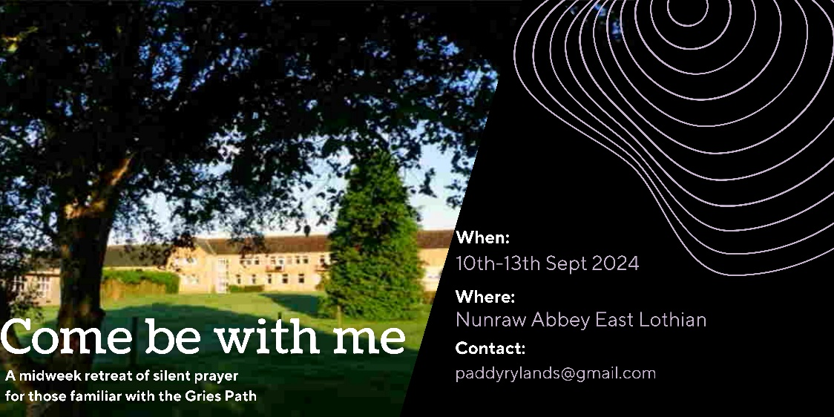
Booking Form Come be with me…
To avoid any confusion, please print details. Thank you.

Name: _________________________________________________________________________
Address: _________________________________________________________________________
_________________________________________________________________________
Contact number: ___________________________________________________________
Email: ___________________________________________________________________

A brief description of your experience of the Gries Path of Prayer:
__________________________________________________________________________________________________________________________________________________
__________________________________________________________________________________________________________________________________________________

I would like to book a place on the Midweek Retreat at Nunraw Abbey. 10th – 13th Sept 2024
*I enclose a cheque for/have transferred £100 deposit and understand the remaining balance is to be paid by 10th August 2024.
Signed:__________________________________________________________________
Date: _________________________ PTO
A word about payment:
Please make cheques payable to P J Rylands and post to Flat 22, Barton Court, The Triangle, Sidmouth. Devon EX10 8PF. If you prefer to make a bank transfer, please contact Paddy directly for bank account details: paddyrylands@gmail.com

For practical reasons, deposits are non-refundable. If this is a concern, please contact Paddy Rylands

All information on the form will be treated in the strictest confidence in accordance with guidelines for data Protection. If you have any concerns do not hesitate to contact the Retreat Co-ordinator Paddy Rylands.

