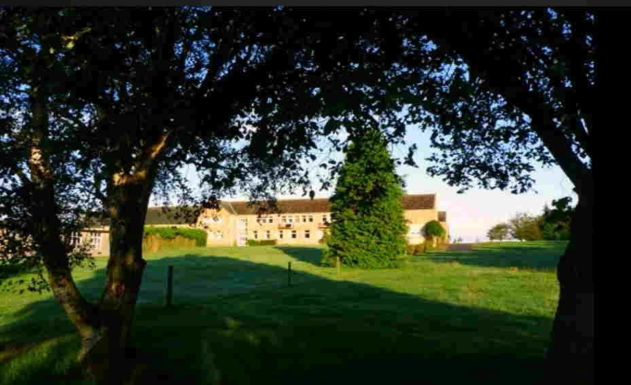

|  |
| --- |
| **Come be with me**  **A midweek retreat**  **for those familiar with the *Gries Path***    **Ω**  **Tuesday 10th—Friday 13th Sept 2024**  **Nunraw (Sancta Maria) Abbey**  **Garvald, Haddington**  **East Lothian**  **Scotland** |

‘There are many paths to contemplation. I show you just one of them. I do not want to exalt my way above others.   
On the contrary, I am very happy that they exist and I appreciate them. I myself have walked the way I describe: should it help someone else to find his or her way I am satisfied.’ (Franz Jalics SJ)

**Who is the retreat for?**

For those familiar with the Gries Path of Prayer

**Dates:**

The retreat will run from   
**4pm Tuesday 10th to   
Friday 13th Sept 2024 (after lunch)**

**Venue:**

Nunraw (Sancta Maria) Abbey

Garvald, Haddington East Lothian, EH41 4LW   
**Visit: nunraw-abbey.com**

**Facilitators:**

**Paddy Rylands—**St Augustine's Old Colwyn Contemplative Prayer Team

**Rachel Inglis—** Epiphany Group of Spiritual Directors

Both facilitators are experienced spiritual directors and very familiar this particular way of contemplative prayer and retreat accompaniment.

**Programme:**

* In the Gries tradition, once we have had a settling in session on the first evening.
* The days will be spent in silent prayer with the opportunity of daily 1-1 sessions with either Rachel or Paddy .
* There will be time, too, to be out in nature.
* Each day there will be the option for joining the monastic community for the celebration of the Eucharist.

**Cost**

A donation of £225 is invited to cover the retreat costs.

The cost includes full board as well as accommodation in en-suite rooms.

The retreat concludes with lunch on the 13th.

**Applications**

It would be helpful to know **before 24th May** whether or not you hope to participate.  
If you have any queries or concerns, please do not hesitate to get in touch.

Please fill an the application form and send to **paddyrylands@gmail.com**